VIETNAM GENERAL CONFEDERATION OF LABOR

**TON DUC THANG UNIVERSITY FACULTY OF INFORMATION TECHNOLOGY**



**SOFTWARE TECHNOLOGY PROJECT**

**COFFEE SHOP MANAGEMENT SYSTEM**

*Instructing Lecturer*: **MR. ĐẶNG MINH THẮNG**

*Student’s name*: **NGUYỄN VI THỊNH – 517H0086**

Class **:17050210**

Course **: 21**

**HO CHI MINH CITY, YEAR 2019.**

VIETNAM GENERAL CONFEDERATION OF LABOR

**TON DUC THANG UNIVERSITY FACULTY OF INFORMATION TECHNOLOGY**



**SOFTWARE TECHNOLOGY PROJECT**

**COFFE MANAGERMENT SYSTEM**

*Instructing Lecturer*: **MR. ĐẶNG MINH THẮNG**

*Student’s name*: **NGUYỄN VI THỊNH – 517H0086**

Class **:17050210**

Course **: 21**

**HO CHI MINH CITY, YEAR 2019.**

**ACKNOWLEDGEMENT**

In order to make this report complete and achieve good results, we have received the support and assistance of many teachers and classmates.

With deep affection, sincerity, we express deep gratitude to all individuals and agencies who have helped us in our study and research.

First of all, I would like to express a special appreciation to Ton Duc Thang University’s teachers for their conscientious guidance and advices throughout the last semester by gave me their modern outlook and meticulous supervision to carry out the job perfectly.

Especially we would like to send our sincere thanks to Mr. Dang Minh Thang has paid attention, help, guide us to complete the report well over the past time.

We would like to express our sincere gratitude to the leadership of Ton Duc Thang University for supporting, helping and facilitating us to complete the report well during the study period.

With limited time and experience, this report can not avoid mistakes. We are looking forward to receiving advice and comments from teachers so that we can improve our awareness, better serve the practical work later.

We sincerely thank you!

**THE PROJECT WAS COMPLETED AT TON DUC THANG UNVERSITY**

I pledge that this is a product of our own project and is under the guidance of Mr Le Minh Hung. The content of research, results in this subject is honest and not published in any form before. The data in the tables used for the analysis, comment, and evaluation were collected by the authors themselves from various sources indicated in the reference section. Beside that project also use some comments and compliment of another authors

**If any fraud is found, I am fully responsible for the content of my project.** Ton Duc Thang University is not involved in any copyright infringement or copyright infringement in the course of implementation (if any).

*TP. Hồ Chí Minh, ngày 08 tháng 12 năm 2019*

*Tác giả*

*(ký tên và ghi rõ họ tên)*

*Nguyễn Vi Thịnh*

**EVALUATION OF INSTRUCTING LECTURER**

**Confirmation of the instructor**

_______________________________________________________________________________________________________________________________________________________________________________________________________________________________________________________________________________________________________________________________________________________________________________________________________________

Tp. Hồ Chí Minh, ngày tháng năm

(kí và ghi họ tên)

**The assessment of the teacher marked**

_______________________________________________________________________________________________________________________________________________________________________________________________________________________________________________________________________________________________________________________________________________________________________________________________________________

Tp. Hồ Chí Minh, ngày tháng năm

(kí và ghi họ tên)

**SUMMARY**

To overcome the difficulties of managing a food store requires software support. By surveying, analyzing and designing steps to create a software that can support the management work. This report will cover all the steps to complete a piece of software. The content consists of 3 chapters:

• Chapter 1: Introduction

• Chapter 2: System analysis and design

• Chapter 3: Software interface design**CATEGORY**

ACKNOWLEDGMENTS 2

SUMMARY 5

TABLE OF CONTENT 6

CHAPTER 1 - INTRODUCTION 1 11

1. Why choose a topic 11

2. Current situation survey 12

2.1. Actual situation 12

3. Overview of import and sales proces 19

4. Functions of the system 19

Chapter 2: System analysis and design 21

1. Actor and usecase 21

1.1. Actor 21

1.2. Usecase 21

2. Usecase 22

2.1. Diagram usecase 22

2.2. usecase actor Manager 23

2.3.usecase actor Employee 24

3.Usecase 25

4. Sequence Diagram 47

5. Class Diagram 55

Chapter 3: Software interface design 59

Conclude 69

REFERENCES 70

LIST OF TABLES, DRAWINGS, GRAPHICS

**LIST OF FIGURES**

Image 1. Illustrating images 1 16

Image 2: Illustrating images 2 17

Image 3: Distribution chart of coffee roaster 18

Image 4: General usecase diagram 22

Image 5: Usecase diagram by actor manager 23

Image 6: Usecase diagram by actor Staff 24

**…**

**CHAPTER 1 - INTRODUCTION**

1. **The reason for choosing a topic**

With the increasing number of customers in the coffee shop business, the managerial jobs of the store also face many difficulties, such difficulties may be: errors when recording books, statistics. list reports, errors in the process of importing and exporting, managing and calculating salaries for employees ...

Based on the difficulties found directly at the current part-time job, after surveying and coming up with ideas, I conducted analysis and design to write a Coffee Management Software to overcome the problems. that restriction, optimizing the work for managers, helping managers to manage everything simply and quickly, employees can do the job more easily.

1. **Current status survey**

**2.1** **Actual situation**

Currently, information technology is considered as a key industry in the country, especially the developing and operating countries of modernization to make a payment. Information and development areas will be supported by the public to support data collection and development. If you want to develop information, you need to apply chemical information to all the assets. Accompanied by all sectors.

Along with the rapid development of the computer industry, the new products will become more diverse, rich, complete and effective for human. Today's products are becoming more and more supportive for consumer use, fast processing times, and a small number of products to be used high automatic.

Therefore, in terms of software development, the requirement is not only an official proposal to be verified, dealt with, but also to meet other requirements like: friendly interface, modeling is done on the computer to be used, familiarity, calculation, high security ... The products help save a lot of time, the work is also supported, increased accurate and effective work.

In fact, the management of the cafe if there is no support for information.

It is recommended that the management of the management system is quite diverse, divided into a number of stages that can be managed. Coffee management: Management of employees (employees working on a shift or day basis), payment management, etc. These jobs require a lot of time. This is due to the fact that accuracy and efficiency are not high, making the system fair and unproductive. Some of the research, statistics, and performance of the information were quite good. There are also a number of difficult issues due to a very low number of customers, low rates, poor performance, etc. While these services can be very difficult. How to normalize a way easy to look. Some help for information, management

It will be profitable, fast and efficient. It is one of the most important things in the industry to be able to save the first time in the current coffee shop with an increasing number of customers. In order for determined customers to be more accurate and quick, the customers have trusted the goods in order to manage. This is especially in the accounting and management of goods. Because of the success of the shop is currently performing a lot of work: trading information about goods in a lot of time and inaccuracy. Proposal

- Supporting information on commodity production, income, and expenses

- Difficulties in the process to make statistical reports, especially when there is a problem, the situation shows that it is necessary to build a system of responding information. Get the following pipes:

+ Storage all food items in the menu order

+ Delete food items in the order menu

+ A list of food items in the market

- Management staff

- Statistics number of employees.

- Printed goods to sell quickly.

- Able to record long-term information to find out quickly when is done.

- There is a discount on the offer.

- Revenue statistics

- Report

- Charge

**3. GENERAL DESCRIPTION OF THE IMPORT AND GOODS PROCESS SELL**

**3.1** I**mport goods**

The shop will be provided by different dealers depending on the order of the bar by the dispensing department. Imported to the dispensing department to check if it has the same quality as required or not - if successful, the item will be imported. Compare request to purchase with items, dispensing department will advance on the receipt of goods to transfer to the cashier. At the same time recorded in the export, import goods and dispensers will bear preservation responsibility. If goods are unsatisfactory, feedback. Check with the dealers. When the cashier pays the bill the bill will be issued.

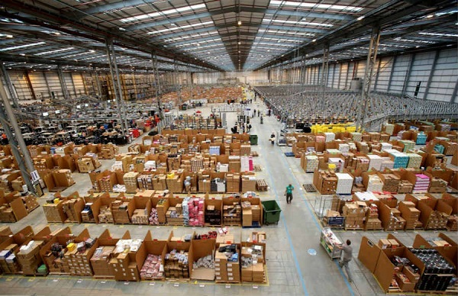

Image 1: Illustrating images 1

**3.2 Sell**

When the customer enters the restaurant, the customer service department will send the Menu to the customer. For drinks, there will be 2 different ticket requests for dispensing booth 1, transfer it to the cashier's counter and enter into the machine count. Based on the customer's request, the dispensing team will prepare items. Drinks to guests and the catering department is responsible for transferring drinks. When considering that an item is running out of dispensing, the quantity of the necessary goods and the owner of the store must be returned. Any time guests request payment will receive a bill. Based on the invoice and the actual number used, the customer will pay. The cashier will print the payment slip for the guest and save the data to the computer for daily monitoring.

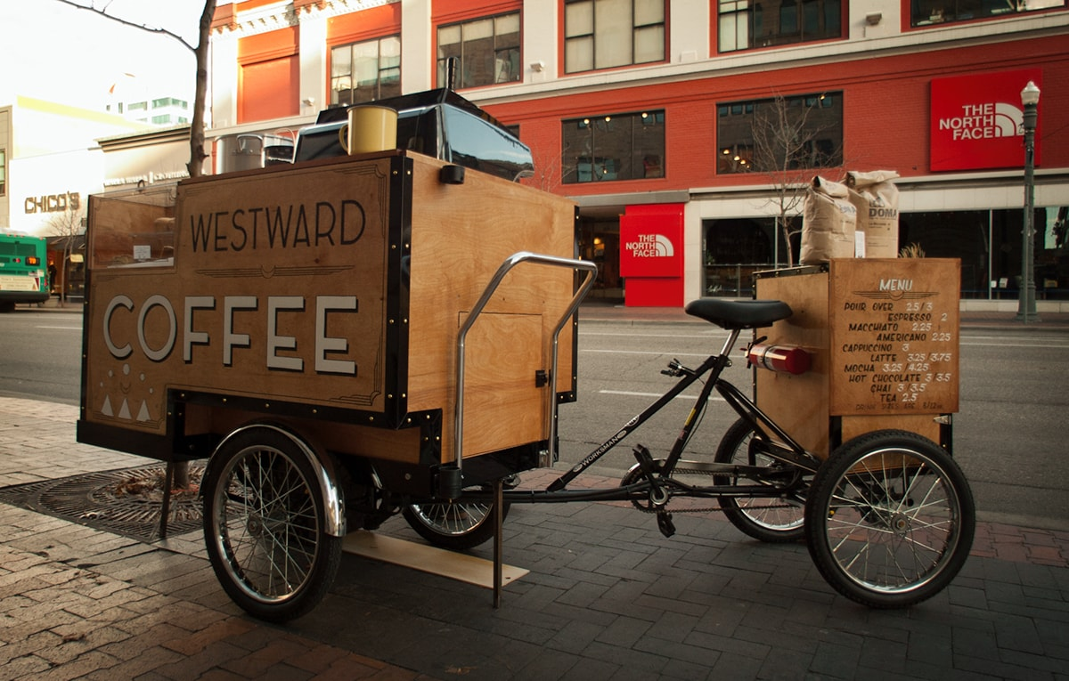

Image 2: Illustrating images 2

DISTRIBUTION CHART:

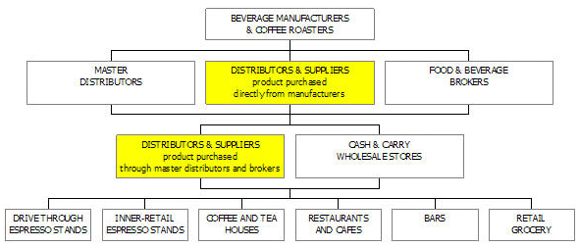

Image 3: Distribution chart of coffee roaster

**4.** **FUNCTION OF THE SYSTEM**

Entry requirements: dispensers based on the Menu

of the store, which will require purchasing the required items set. Or when all items are out, a door will be reported imported goods.

Check the goods: the imported goods will be mixed check whether we meet the standards for quantity and quality amount or not. If it is, then warehousing, otherwise. Send feedback to the agent.

Import goods into the warehouse: goods will be delivered by dealers received and preserved by the dispensing department.

Create import in voices: Based on the number of goods that dealers provide

If so, the dispensing department will issue a receipt for the goods agents to agents ask the accounting department to pay money line.

Save to the import and export books: The imported goods will be saved to the books cargo tracking to facilitate the tracking of goods

Write a check: when you receive a payment request goods to the dealer, the accounting department will confirm, bar pay and write checks.

Record the income and expenditure: after payment is completed, the accounting department will record the store's receipts and expenses to make it easy to summarize sales of the store.

Request drinks: based on the restaurant's Menu, guests will call your beverage needs and restorations record on request form.

Serve drinks: from the request sheet of the department guests. The bartender will make drinks for guests and will be served transfer

to the guests.

Write invoice: receive payment request of guests, sets accounting department will charge based on the customer request form already requested.

Write a receipt: based on the actual number of guests using, the accounting department writes a receipt for the actual amount guests must pay.

Save to the tracking book: every day, dispensers will check for statistics. From there, you will be asked to import the goods if needed.

Identify incidents: when an unexpected incident occurs. Phase will determine the severity of the incident conduct minutes of handling.

Make a record of the problem: After identifying the problem such as broken

beaker, or damage to its contents or loss of its contents. The shop manager will make a record.

Troubleshooting: Examining the object causing the problem will advance. Pay compensation to customers if the error is due to shop or love demand compensation if the guest is at fault. Enter data into the computer: after receiving oder votes. The cashier's customer will proceed to input on the computer to print out the invoice when the customer requests pay.

Issue sales receipts: upon request of the bar. The cashier's account will print the delivery invoice to oder department to charge.

Make a summary sales report: the store owner will request to summarize the business situation of the store by day, week, month or quarter, year, and the cashier is responsible for summing up the numbers. Whether or not to conduct revenue reports.

CHAPTER 2 - SYSTEM ANALYSIS AND DESIGNCHAPTER 2 - SYSTEM ANALYSIS AND DESIGN

**1. List the actors and usecase**

* 1. **Actor**

Manager

Employees

* 1. **Usecase**
* Sales Manager

• Create retail invoices

•Pay

•Discount

* Manage personal information

• Change of personal information

•Change Password

* Revenue statistics

• Generate revenue report

* Manage drinks

• Updated beverage information

• Looking for a drink

• See a list of drinks

• Add / remove drinks

* Employee manager

• Add / remove employees

• Update employee information

• Reset working hours

• Payroll staff

* Account management

• View account list

•Update account information

• Add / remove accounts

•Reset Password

* Managing import goods

• Create entry form

• Statistics of import slips

* Other Usecase

•Log in

•Log out

## Usecase diagram

# General usecase diagram

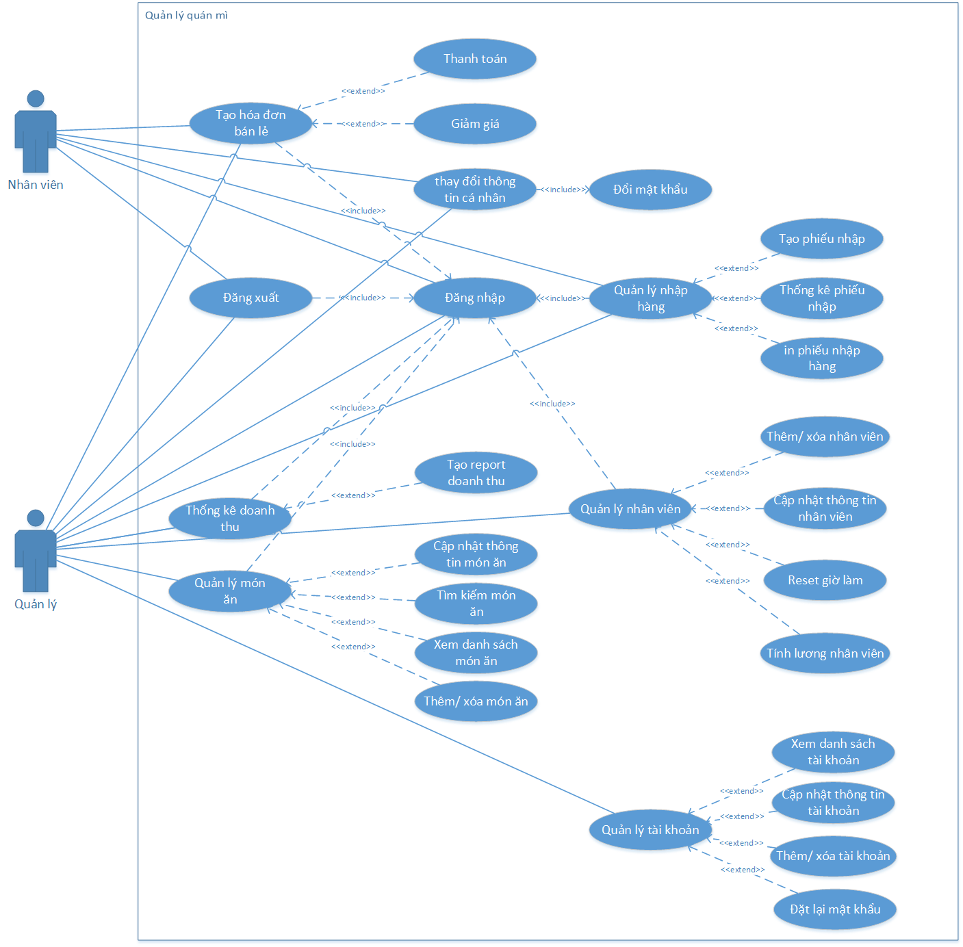

# Image 4: General usecase diagram

# Usecase diagram by actor manager

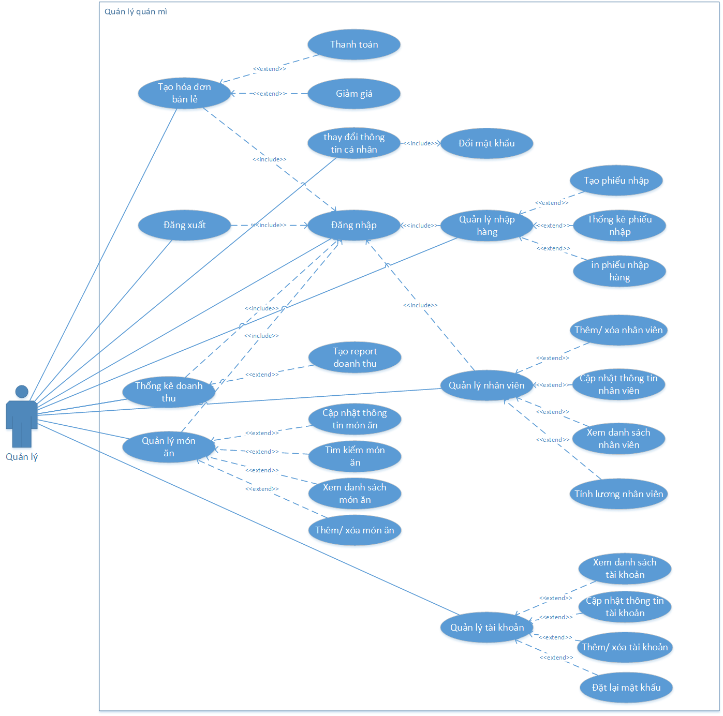

# Imagine 5: Usecase diagram by actor manager

# Usecase diagram by actor Staff

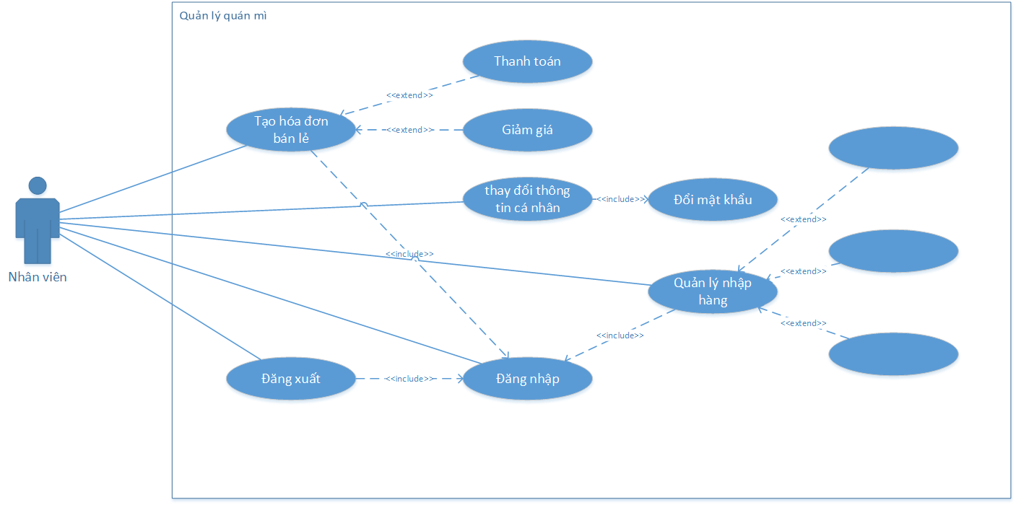

Image 6: Usecase diagram by actor Staff

## Usecase specification

# Usecase login specification

|  |  |  |
| --- | --- | --- |
| Use case | Log in | |
| Actor | Management staff | |
| Summary | The user uses an account with administrative or administrative rights to log in to the system to use the features | |
| Trigger | Click the login button after entering the Username and Password | |
| Pre-condition | Account was created earlier | |
| Flow of event | Actor | System |
| 1. Software startup staff  3. User enters the full UserName and Password | 2 . The system displays a login form that requires entering the Username and Password  4. The system checks usernames and password after user input  5. Login successfully, the system shows up the user interface  6. End |
| Exception | - If the user entered the wrong account and password, the form displays the error message "the wrong account or password" and the form requires a new login again.  - The user has left the username or password blank, the system displays the form asking for full information. | |

Table 1: Usecase login specification

# logout usecase specification

|  |  |  |
| --- | --- | --- |
| Use case | Log out | |
| Actor | Accounting, management | |
| Summary | Users Log out of the system when not in use | |
| Trigger | Click the logout button in the personal information tab | |
| Pre-condition | Account previously logged in | |
| Flow of event | Actor | System |
| 1. After logging into the system, users select "Personal information => log out" | 2 . The system exits the login form  3. Finish |
| Exception |  | |

Table 2: *1.1. logout usecase specification*

# The usecase specification changes account information

|  |  |  |
| --- | --- | --- |
| Use case | Change account information | |
| Actor | Management staff | |
| Summary | Users change the username and password information logged into the software, in addition to changing the display name when logging into the software. | |
| Trigger | Click on the personal information tab | |
| Pre-condition | Account previously logged in | |
| Flow of event | Actor | System |
| 1. After logging into the system, users select "Personal information"  3. The user enters the information that needs to be changed but cannot change the username  5. Users select the "Update" button | 2 . The system displays the form of personal information including username, display name  4. The system will ask for a password if the user has not entered it  6. Password information checking system  7. Update the changed user information in the database  8. Finish |
| Exception | - User does not enter full information, the system displays a notice requiring full information  - The user has entered the wrong password, the system displays an incorrect password notification without updating new information | |

Table 3: The usecase specification changes account information

# Usecase password change specification

|  |  |  |
| --- | --- | --- |
| Use case | Change Password | |
| Actor | Management staff | |
| Summary | Users change the login password to the software | |
| Trigger | Click on the personal information tab | |
| Pre-condition | Account previously logged in | |
| Flow of event | Actor | System |
| 1. After logging into the system, users select "Personal information"  3. Users enter the old password, enter a new password and re-enter the new password to confirm  5. Users select the "Update" button | 2 . The system displays a personal information form and a password change function  4. The system will ask for a password if the user has not entered it  6. Password information checking system  7. Update the changed user information in the database  8. Finish |
| Exception | - User does not enter full information, the system displays a notice requiring full information  - The user has entered the wrong password, the system displays an error message without updating new information  - The user enters a new password and confirms that the new password is not the same, the software displays the message asking for the correct new password and asking the user to enter it again | |

Table 4: Usecase password change specification

# The usecase specification creates a retail invoice

|  |  |  |
| --- | --- | --- |
| Use case | Create retail invoices | |
| Actor | Management staff | |
| Summary | Users create billing invoices for customers when they want to pay | |
| Trigger | Click the payment button on the dining table management interface, create an invoice | |
| Pre-condition | - Account previously logged in | |
| Flow of event | Actor | System |
| 1. Log into the system  3. User selects table to create invoice and type of dish  5. The user chooses the dish and quantity requested by the customer, repeating the above process until the customer has finished the order  8. User enters the amount given by the guest  10. The user clicks the payment button  12. User selects payment confirmation | 2. Display up dining table management interface - create invoices  4. The system changes the status of the selected table to "human" and loads all the dishes according to the category of food the user has chosen  6. The system displays a list of dishes, quantities and unit prices according to the number of dishes that the user has selected  7. The system displays the total amount that customers need to pay and requires users to enter the amount of money given  9. The software displays the excess amount  11. The software displays information such as total amount, discount (if any), the amount to be paid and requires the user to confirm  13. System transforms table information into "Blank"  14. Finish |
| Exception | - Người dùng nhập số tiền khách đưa nhỏ hơn số tiền thanh toán, hệ thống hiện thị thông báo và yêu cầu nhập lại | |

Table 5: The usecase specification creates a retail invoice

# Discount usecase specification

|  |  |  |
| --- | --- | --- |
| Use case | Discount | |
| Actor | Management staff | |
| Summary | When customers use coupons, users enter% discount on the software, the blanket will deduct the discount amount from the total payment | |
| Trigger | Choose a discount percentage | |
| Pre-condition | Maximum percentage discount is 80% | |
| Flow of event | Actor | System |
| 1. After creating the payment invoice, the user enters the discount percentage into the "discount" box  2. Click the payment button | 3. The system checks conditions and deducts% discount from the total payment, and saves the discount to the database.  4. Finish |
| Exception | - Users do not enter a discount, the system claims a 0% discount | |

Table 6: Discount usecase specification

# Usecase invoice statistics specification

|  |  |  |
| --- | --- | --- |
| Use case | Invoice statistics | |
| Actor | Manage | |
| Summary | Users can view all generated invoices from a selected date range | |
| Trigger | After selecting the "statistics" tab, click the statistics button | |
| Pre-condition | -Account login with administrative rights | |
| Flow of event | Actor | System |
| 1. User selects tab "statistics" in Admin function  3. User selects start date, end date and click the statistics view button | 2. The system displays a form to enter the start and end dates for viewing statistics. When users do not select the software, the default is the beginning of the month and the end of the month  4. The information system of all invoices has been created from the selected date to the selected end date  5. Finish |
| Exception | - Choose a start date greater than the end date or current date, the software reports an error and asks the user to select again | |

Table 7: Usecase invoice statistics specification

# The usecase specification generates invoice reports

|  |  |  |
| --- | --- | --- |
| Use case | Create invoice statistics report | |
| Actor | Manage | |
| Summary | After viewing the invoice statistics successfully, users can create report tables to serve different needs | |
| Trigger | Click the "Create report" button | |
| Pre-condition | -Account login with administrative rights | |
| Flow of event | Actor | System |
| 1. After selecting invoice statistics. Click on the "Create report" button.  3. Users can use functions such as: print, excel export, pdf .. | 2. The software displays the previously formatted report table with full information of the list of invoices  4. Finish |
| Exception | -The user has not yet selected to view the invoice statistics, the system requires users to choose to view the previous statistics to export the report | |

Table 8: The usecase specification generates invoice reports

# Usecase specification adds / deletes drinks

|  |  |  |
| --- | --- | --- |
| Use case | Add / remove drinks | |
| Actor | Manage | |
| Summary | Users can add or delete dish information as needed | |
| Trigger | Select the "Drink" tab in the Admin section, click the add or delete button | |
| Pre-condition | -Account login with administrative rights | |
| Flow of event | Actor | System |
| 1.The user selects the 'Drink' tab in the admin section  ‘  3. The user enters the required form information | 2. The system displays the form to enter information such as: Name of the dish, list, price  4. The system checks the information completely and saves itself in the database  5. Finish |
| Exception | 1. Users do not enter full information from, the software notices "Do not leave blank" and requires re-enter 2. The user entered the wrong format, the software reported an error and asked to retype it | |

Table 9: Usecase specification adds / deletes drinks

# The usecase specification updates beverage information

|  |  |  |
| --- | --- | --- |
| Use case | Updated beverage information | |
| Actor | Manage | |
| Summary | Users can edit dish information as needed | |
| Trigger | Select the "Drink" tab in the Admin section, click the update button | |
| Pre-condition | -Account login with administrative rights | |
| Flow of event | Actor | System |
| 1.The user selects the 'Drink' tab in the admin section  2. User selects the line containing the dish information to edit  4. Users change the information displayed on the textbox | 3. The system displays information such as: Name of the dish, list, price of textbox  5. The information checking system is complete and saves itself in the database  6. Finish |
| Exception | 1. 1. Users do not enter full information from, the software notices "Do not leave blank" and requires re-enter 2. 2. The user entered the wrong format, the software reported an error and asked to retype it | |

Table 9: The usecase specification updates beverage information

# The usecase specification looks for drinks

|  |  |  |
| --- | --- | --- |
| Use case | Looking for a drink | |
| Actor | Manage | |
| Summary | Users can search for dish information by keywords related to that dish | |
| Trigger | Select the "Food" tab in the Admin section, click the search button | |
| Pre-condition | -Account login with administrative rights | |
| Flow of event | Actor | System |
| 1.The user selects the 'Food' tab in the admin section  2. The user enters the information to be searched into the textbox  4. Users can select the information displayed after searching to view detailed information | 3. The system displays information related to the keyword the user enters  5. Finish |
| Exception |  | |

Table 11: The usecase specification looks for drinks

# Usecase specification see the list of drinks

|  |  |  |
| --- | --- | --- |
| Use case | See the list of dishes | |
| Actor | Manage | |
| Summary | Users can view a list of all food information in the software | |
| Trigger | Select the "Food" tab in the Admin section, click the search button | |
| Pre-condition | -Account login with administrative rights | |
| Flow of event | Actor | System |
| 1.The user selects the 'Food' tab in the admin section  2. User selects View button  4. User can select an information display to see detailed information | 3. The system displays a list of food information  5. Finish |
| Exception |  | |

Table 12: Usecase specification see the list of drinks

# The usecase specification adds employees

|  |  |  |
| --- | --- | --- |
| Use case | Add staff | |
| Actor | Manage | |
| Summary | The manager uses this function to add new employees to the store. Additional employees include information as well as the employee's working time | |
| Trigger | Click admin, then select the staff tab and then add | |
| Pre-condition | Account previously logged in | |
| Flow of event | Actor | System |
| 1. After logging into the system, users select "admin". Then select the staff tab.  3. User enters the information of new employee. Then click "more". | 2 . The system displays a form to enter information of new employees  4. The system will display a list of existing and newly added employees.  5. Finish |
| Exception | - User does not enter full information, the system displays a notice requiring full information | |

Table 13: The usecase specification adds employees

# The usecase specification updates employee information

|  |  |  |
| --- | --- | --- |
| Use case | Update staff | |
| Actor | Manage | |
| Summary | Managers use this function to change some personal information of an employee. | |
| Trigger | Click admin, then select the staff tab, then select update | |
| Pre-condition | Account previously logged in | |
| Flow of event | Actor | System |
| 1. After logging into the system, users select "admin". Then select the staff tab.  3. User selects an employee from the list.  4. What information do users want to change then click that information then enter new information and click "update" | 2. The system displays a list of employees in the store  4. The system will display the employee's information form (including working hours)  5. The system updated successfully |
| Exception | - If the user has left the information blank, the system will display a notice requesting full information | |

Table 14: The usecase specification updates employee information

# Usecase payroll specìication

# 

|  |  |  |
| --- | --- | --- |
| Use case | Calculation of wages | |
| Actor | Manage | |
| Summary | The manager uses this function to calculate the monthly salary for each employee | |
| Trigger | Click admin, then select the staff tab | |
| Pre-condition | Account previously logged in | |
| Flow of event | Actor | System |
| 1. After logging into the system, users select "admin". Then select the staff tab.  3. User selects an employee from the list.  5. Users only need to enter the number of hours that employee worked in a day and then press "update".  7. At the end of the month, users only need to get the "Total salary" number to pay employees | 2. The system displays a list of employees in the store  4. The system will display the employee information form and calculate the salary for the employee  6. The system will update the total working hours and calculate the total hourly wage that employees worked |
| Exception | - If the user enters a negative number of hours, the software will not report an error but will deduct it from the total working hours of the employee | |

Table 15: Usecase payroll specification

* 1. **Đặc tả usecase reset giờ làm**

|  |  |  |
| --- | --- | --- |
| Use case | Reset working hours | |
| Actor | Manage | |
| Summary | Managers use this function to reset the employee's working hours after the end of each month after pay. | |
| Trigger | Click admin, then select the staff tab | |
| Pre-condition | Account previously logged in | |
| Flow of event | Actor | System |
| 1. After logging into the system, users select "admin". Then select the staff tab.  3. User selects an employee from the list.  5. Users click on "reset working hours" to start a new month of that employee  7. Staff click "update" | 2. The system displays a list of employees in the store  4. The system will display the employee information form and calculate the salary for that employee  6. The system will reset that employee's working time to “0”  8.System updated successfully |
| Exception |  | |

Table 16: The usecase specification resets working hours

# The usease specification resets the password

|  |  |  |
| --- | --- | --- |
| Use case | Reset Password | |
| Actor | Manage | |
| Summary | Manager uses this function to reset passwords for employee accounts | |
| Trigger | Click admin, then select the account tab | |
| Pre-condition | Account previously logged in | |
| Flow of event | Actor | System |
| 1. After logging in to the system, users select "admin". Then select the account tab.  3. The user clicks the account and wants to reset the password  5. Users click on "Reset password" | 2 . The system displays a list of accounts in the system  4. The system displays information of the account that the user clicked on.  5. The system will reset to the password as "0". Notice of success |
| Exception |  | |

Table 17: The usease specification resets the password

# The usecase specification adds an account

|  |  |  |
| --- | --- | --- |
| Use case | More account | |
| Actor | Manage | |
| Summary | The manager using this function adds an account login to the system for employees | |
| Trigger | Click admin, then select the account tab | |
| Pre-condition | Account previously logged in | |
| Flow of event | Actor | System |
| 1. After logging in to the system, users select "admin". Then select the account tab.  3. User enter account information in form then click "add" | 2 . The system displays the list of accounts in the system and the account information form  4. The system will add the newly created account to the account list. |
| Exception | * If the user has an existing account name, the system will report an error * User does not enter complete system information displayed. Notifications require full information entry | |

Table 18: The usecase specification adds an account

# The usecase specification updates account information

|  |  |  |
| --- | --- | --- |
| Use case | Update account information | |
| Actor | Manage | |
| Summary | Manager uses this function to update some information for the account. | |
| Trigger | Click admin, then select the account tab | |
| Pre-condition | Account previously logged in | |
| Flow of event | Actor | System |
| 1. After logging in to the system, users select "admin". Then select the account tab.  3. Click on the account you want to update  5. If you want to change anything, select that information and change and click "update" | 2 . The system displays the list of accounts in the system and the account information form  4. The system displays account information that the user has selected.  6. Notification system updated successfully |
| Exception | * Users cannot change the account name * User does not enter complete system information displayed * Notifications require full information entry | |

Table 19: The usecase specification updates account information

# Usecase specification see account list

|  |  |  |
| --- | --- | --- |
| Use case | See list of accounts | |
| Actor | Manage | |
| Summary | Manager uses this function to view the list of accounts in the system | |
| Trigger | Click admin, then select the account tab | |
| Pre-condition | Account previously logged in | |
| Flow of event | Actor | System |
| 1. After logging in to the system, users select "admin". Then select the account tab. | 2 . The system displays the list of accounts in the system and the account information form |
| Exception |  | |

Table 20: Usecase specification see account list

# The usecase specification generates import orders

|  |  |  |
| --- | --- | --- |
| Use case | Create a bill of entry | |
| Actor | Manage | |
| Summary | Users can create and print import orders | |
| Trigger | Click the Import tab | |
| Pre-condition | Account previously logged in | |
| Flow of event | Actor | System |
| 1. User selects the import function  3. The user enters information into the input form information box such as: employee entered and date entered  4. Select the "add new" button  6. After the application form, the user will continue to add information about the input form, such as product, quantity, unit and unit price. | 2. The system displays the right frame is the invoice information, the left is the invoice details column  5.The software saves the information of the input form and announces more success  7. The software stores information and reports success  8. Finish |
| Exception | - The user leaves out any information, the software reports an error and requires re-enter | |

Table 21: The usecase specification generates import orders

# Usease specification of input statistics

|  |  |  |
| --- | --- | --- |
| Use case | Statistics votes entered | |
| Actor | Manage | |
| Summary | The manager uses this function to record the entry of that month or 1 year ... | |
| Trigger | Click admin, then select the account tab | |
| Pre-condition | Account previously logged in | |
| Flow of event | Actor | System |
| 1.After logging into the system, users select the import tab.  2.Select the form of statistics (by month, by year).  3. Request printing of entry form | 2. The system displays a form for users to enter shipment information and list of imported shipments.  4. The system will notify the entry entered in the month or year  5. Print the entry form |
| Exception |  | |

Table 22: Usease specification of input statistics

## Sequence Diagram

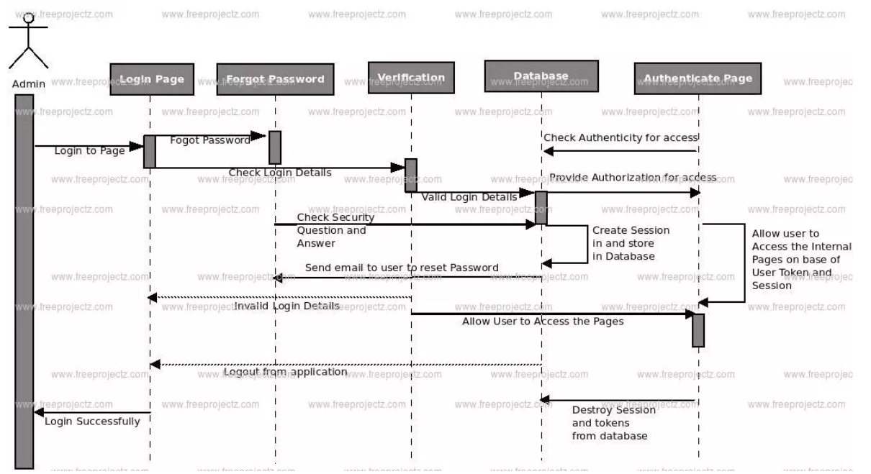

## Image 7: Login Sequence Diagram of coffee management system (1)

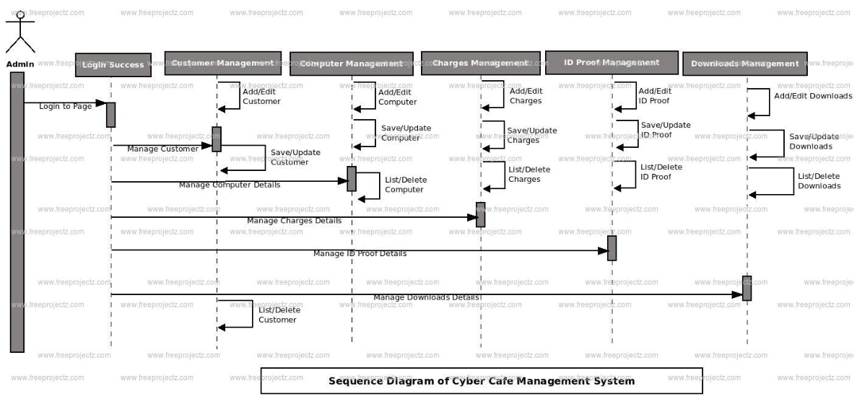

## Image 8: Login Sequence Diagram of coffee management system (2)

## Class Diagram

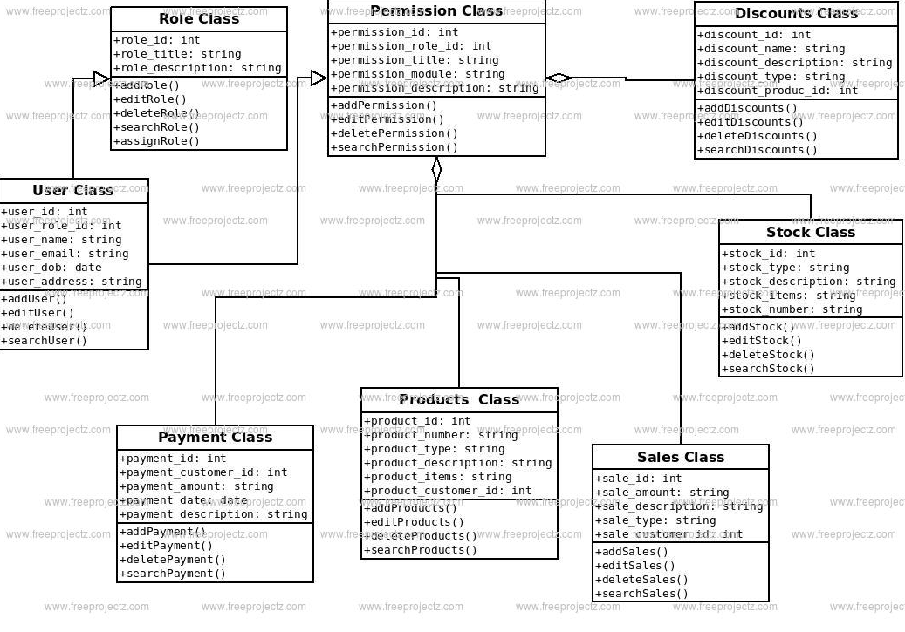

Image 9: Class diagram of coffee management system

**CHAPTER 3 - SOFTWARE INTERFACE DESIGN**

1. **Login interface**

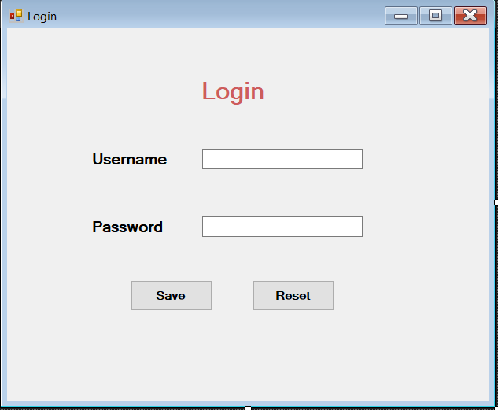

Image 10: Login interface

1. **Main interface**

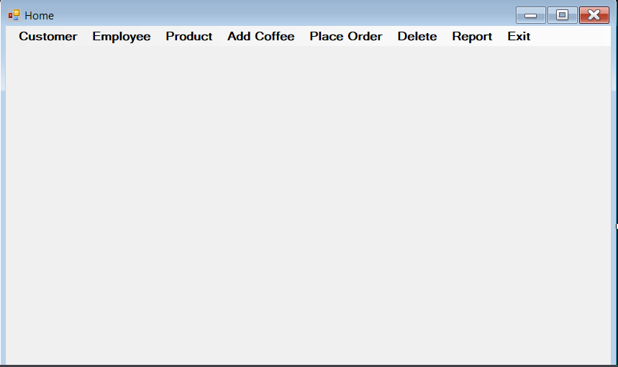

Image 11: main interface

1. **Custom form interface**

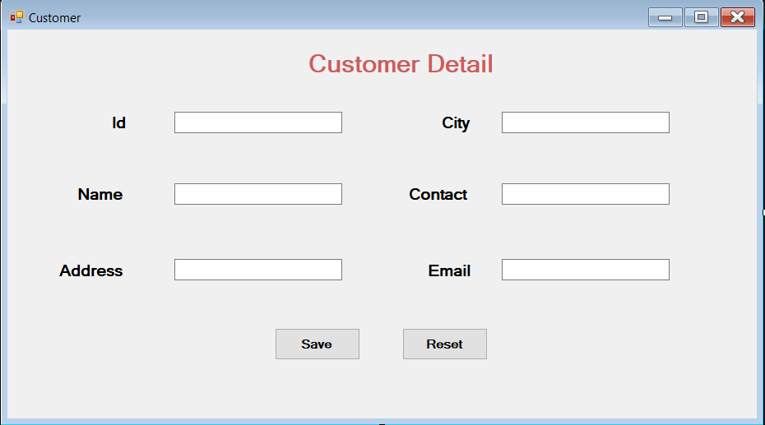

Image 12: Custom form interface

1. **Employee form interface**

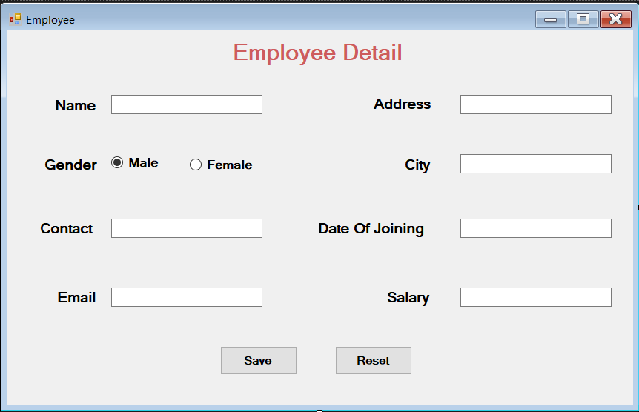

Image 13:Employee form interface

1. **Product detail interface**

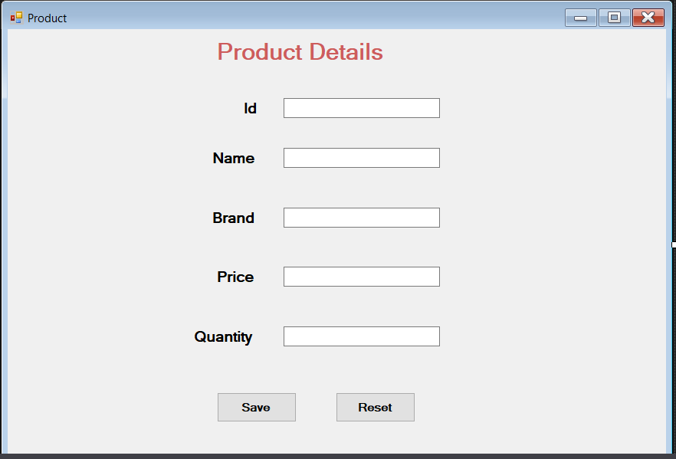

Image 14: Product detail interface

1. **Place order form interface**

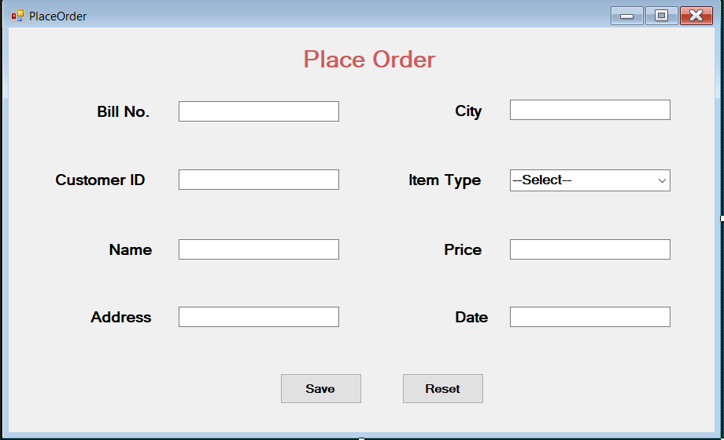

Image 15: Place order form interface

1. **Add coffee interface**

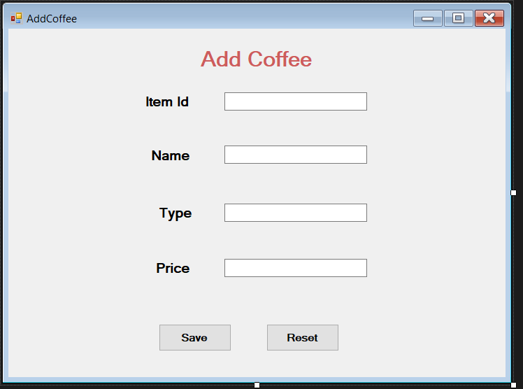

Image 16: add coffee interface

1. **Place order Interface**



**Image 17: Place order interface**

1. **Delete form interface**

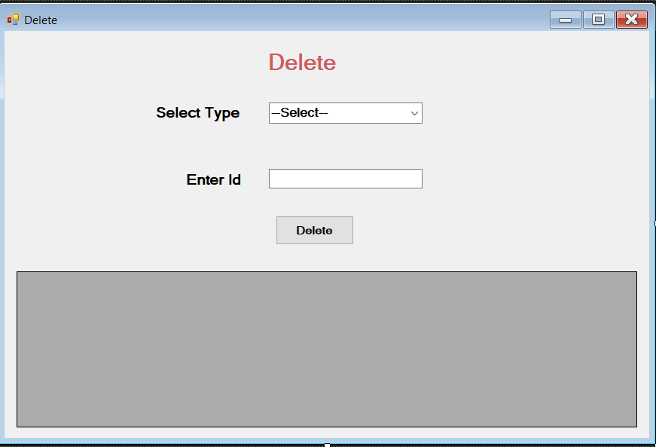

Image 18: Delete form interface

**10. Report form interface**

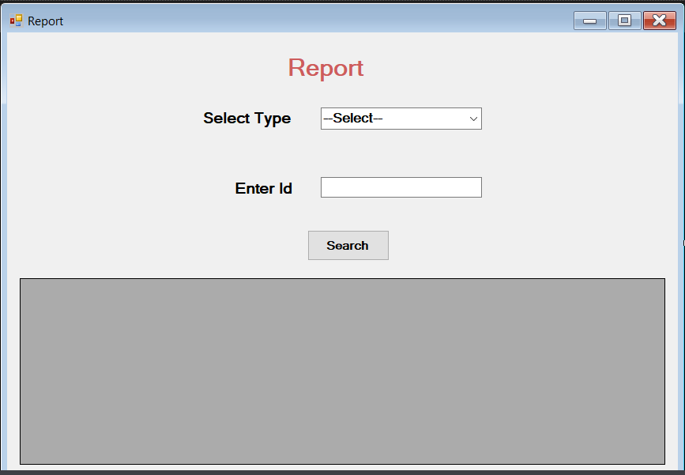

Image 19: Report form interface

**CONCLUDE**

Through the process of analyzing and designing them, finding contents on the internet, we have completed a cafe management application with the main functions such as sales management, invoices, sales statistics. collecting, managing employees and staff salaries, managing imports ...

Besides, there are still some functions that have not yet been implemented and not yet completed. But do not stop there, we still try to learn to edit and complete the application in the future.

**REFERENCES**

[1] <https://viblo.asia/p/mo-hinh-quan-he-thuc-the-entity-relationship-model-oOVlYEenl8W>

[2] <http://www.fts.com.vn/su-dung-phan-mem-quan-ly-ban-hang-trong-doanh-nghiep-hien-nay.html>

[3] <https://iviettech.vn/blog/543-ban-ve-use-case-use-case-diagram.html>

[4] <https://iviettech.vn/blog/1358-thuc-hanh-xay-dung-sequence-diagarm.html>

[5] Tài liệu lập trình C# – ĐH KHTN